**Semantic Web Assignment 2: RDF and RDFS**

**Q 1) RDF data produced from step 2 & 3 of the class exercise (as described in the slides)**

Step 2:

<rdf:RDF

xmlns:rdf=*"http://www.w3.org/1999/02/22-rdf-syntax-ns#"*

xmlns:rdfs=*"http://www.w3.org/2000/01/rdf-schema#"*

xmlns:foaf=*"http://xmlns.com/foaf/0.1/"*>

<foaf:Person rdf:ID=*"me"*>

<foaf:name>Kanika Mathur</foaf:name>

<foaf:homepage rdf:resource=*"https://www.google.com"* />

<foaf:depiction rdf:resource=*"https://www.google.com"*/>

<foaf:phone rdf:resource=*"tel:9547068339"*/>

<foaf:interest rdf:resource=*"*[www.google.com=?Semantic Web](http://www.google.com=?Semantic%20Web)*"* />

<foaf:knows>

<foaf:Person>

<foaf:name>XYZ</foaf:name>

</foaf:Person>

</foaf:knows>

</foaf:Person>

</rdf:RDF>

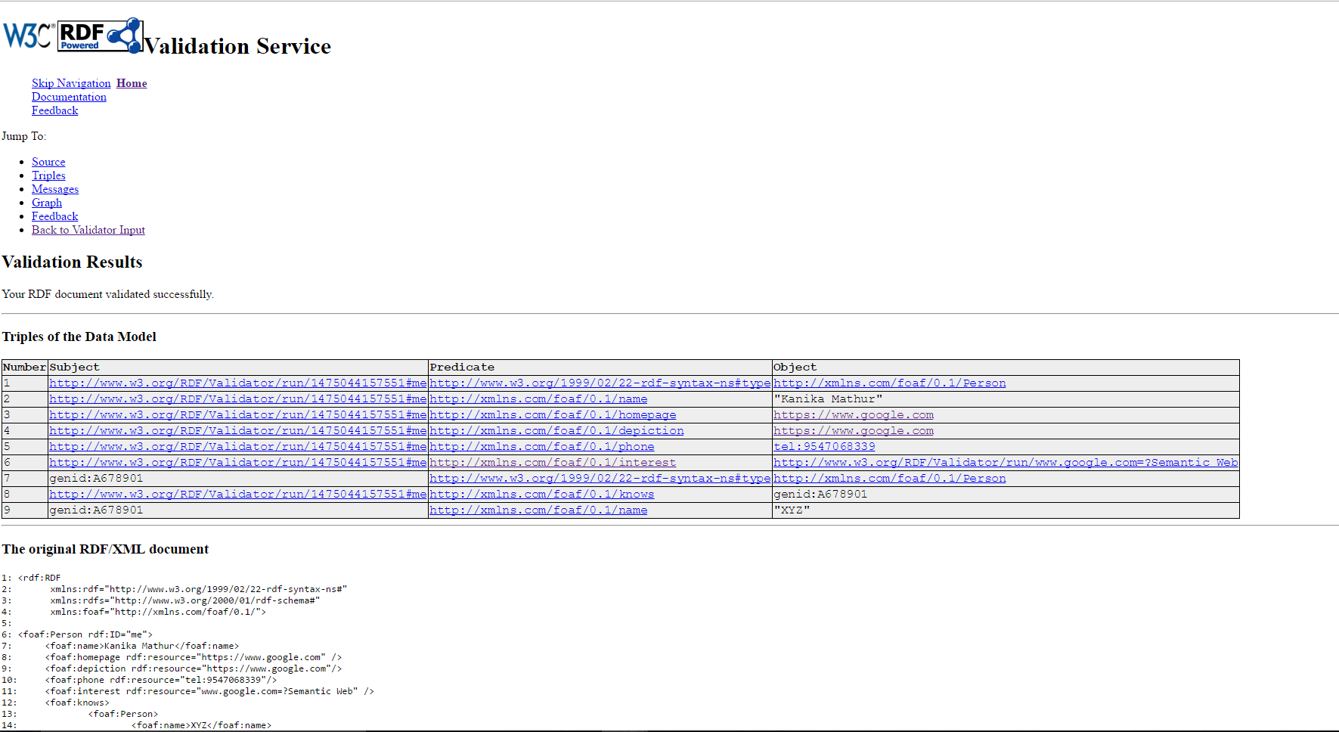

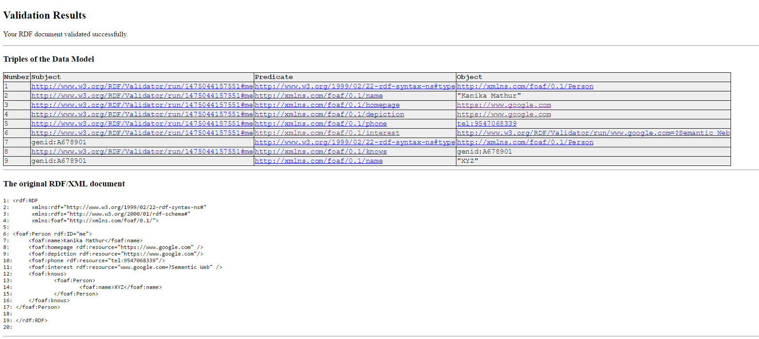

**Q2) RDF data produced from step 4 of the class exercise (as described in the slides)**

Step 3:

**Mbox without hash code:**

<rdf:RDF

xmlns:rdf="http://www.w3.org/1999/02/22-rdf-syntax-ns#"

xmlns:rdfs="http://www.w3.org/2000/01/rdf-schema#"

xmlns:foaf="http://xmlns.com/foaf/0.1/"

xmlns:admin="http://webns.net/mvcb/">

<foaf:PersonalProfileDocument rdf:about="">

<foaf:maker rdf:resource="#me"/>

<foaf:primaryTopic rdf:resource="#me"/>

<admin:generatorAgent rdf:resource="http://www.ldodds.com/foaf/foaf-a-matic"/>

<admin:errorReportsTo rdf:resource="mailto:leigh@ldodds.com"/>

</foaf:PersonalProfileDocument>

<foaf:Person rdf:ID="me">

<foaf:name>Kanika Mathur</foaf:name>

<foaf:title>Ms</foaf:title>

<foaf:givenname>Kanika</foaf:givenname>

<foaf:family_name>Mathur</foaf:family_name>

<foaf:mbox rdf:resource="mailto:mathurkanika1@gmail.com"/>

<foaf:phone rdf:resource="tel:9547068339"/>

<foaf:knows>

<foaf:Person>

<foaf:name>XYZ</foaf:name>

<foaf:mbox rdf:resource="mailto:xyz@gmail.com"/></foaf:Person></foaf:knows></foaf:Person>

</rdf:RDF>

**Mbox with hash code:**

<rdf:RDF

xmlns:rdf="http://www.w3.org/1999/02/22-rdf-syntax-ns#"

xmlns:rdfs="http://www.w3.org/2000/01/rdf-schema#"

xmlns:foaf="http://xmlns.com/foaf/0.1/"

xmlns:admin="http://webns.net/mvcb/">

<foaf:PersonalProfileDocument rdf:about="">

<foaf:maker rdf:resource="#me"/>

<foaf:primaryTopic rdf:resource="#me"/>

<admin:generatorAgent rdf:resource="http://www.ldodds.com/foaf/foaf-a-matic"/>

<admin:errorReportsTo rdf:resource="mailto:leigh@ldodds.com"/>

</foaf:PersonalProfileDocument>

<foaf:Person rdf:ID="me">

<foaf:name>Kanika Mathur</foaf:name>

<foaf:title>Ms</foaf:title>

<foaf:givenname>Kanika</foaf:givenname>

<foaf:family_name>Mathur</foaf:family_name>

<foaf:mbox_sha1sum>090903e96a8a7a8613d0e36ddb984b87f59336a6</foaf:mbox_sha1sum>

<foaf:phone rdf:resource="tel:9547068339"/>

<foaf:knows>

<foaf:Person>

<foaf:name>XYZ</foaf:name>

<foaf:mbox_sha1sum>4eb14d49028a5fbf4222b0790c8950d6ad57fd16</foaf:mbox_sha1sum></foaf:Person></foaf:knows></foaf:Person>

</rdf:RDF>

**Q3) RDF Schema produced from step 5 of the class exercise (as described in the slides)**

RDFS Schema:

<rdf:RDF

xmlns:rdf=*"http://www.w3.org/1999/02/22-rdf-syntax-ns#"*

xmlns:rdfs=*"http://www.w3.org/2000/01/rdf-schema#"*>

<rdfs:Class rdf:ID=*"Person"*>

<rdfs:comment>The class of persons</rdfs:comment>

</rdfs:Class>

<rdfs:Class rdf:ID =*"Teacher"*>

<rdfs:comment>The class of teachers</rdfs:comment>

<rdfs:subClassOf rdf:resource=*"#Person"* />

</rdfs:Class>

<rdfs:Class rdf:ID=*"Student"*>

<rdfs:comment>The class of students</rdfs:comment>

<rdfs:subClassOf rdf:resource=*"#Person"* />

</rdfs:Class>

<rdfs:Class rdf:ID=*"Course"*>

<rdfs:comment>The class of courses</rdfs:comment>

</rdfs:Class>

<rdf:Property rdf:ID=*"has_students"*>

<rdfs:comment>

It relates only course to student.

</rdfs:comment>

<rdfs:domain rdf:resource=*"#Course"* />

<rdfs:range rdf:resource=*"#Student"* />

</rdf:Property>

<rdf:Property rdf:ID=*"has_teacher"*>

<rdfs:comment>

It relates only course to teacher.

</rdfs:comment>

<rdfs:domain rdf:resource=*"#Course"* />

<rdfs:range rdf:resource=*"#Teacher"* />

</rdf:Property>

<rdf:Property rdf:ID=*"has_name"*>

<rdfs:comment>

It is a property of both person and course and takes literals as values.

</rdfs:comment>

<rdfs:comment>

Put person and course in a container since it can take them in any order.

</rdfs:comment>

<rdfs:domain rdf:resource=*"#Course"* />

<rdfs:domain rdf:resource=*"#Person"* />

<rdfs:range rdf:resource=*"http://www.w3.org/2000/01/rdf-schema#Literal"*/>

</rdf:Property>

</rdf:RDF>

**Q4) RDF instance data produced from step 6 of the class exercise (as described in the slides)**

Instance document:

<?xml version=*"1.0"* encoding=*"UTF-8"*?>

<rdf:RDF

xmlns:rdf=*"http://www.w3.org/1999/02/22-rdf-syntax-ns#"*

xmlns:xsd=*"http://www.w3.org/2001/XMLSchema#"*

xmlns:person=*"http://www.mydomain.org/person-ns"*>

<rdf:Description rdf:about=*"Kanika"*>

<person:has_name>Kanika Mathur</person:has_name>

</rdf:Description>

<rdf:Description rdf:about=*"Jyoti"*>

<person:has_name>Jyoti Mathur</person:has_name>

</rdf:Description>

<rdf:Description rdf:about=*"Anil"*>

<person:has_name>Anil Mathur</person:has_name>

</rdf:Description>

<rdf:Description rdf:about=*"Mayank"*>

<person:has_name>Mayank Mathur</person:has_name>

</rdf:Description>

<rdf:Description rdf:about=*"Bansal"*>

<person:has_name>Dr Srividya Bansal</person:has_name>

</rdf:Description>

<rdf:Description rdf:about=*"Gaffar"*>

<person:has_name>Dr Ashraff Gaffar</person:has_name>

</rdf:Description>

<rdf:Description rdf:about=*"SER 594"*>

<person:has_name>Software Engineering</person:has_name>

<person:has_teacher rdf:resource=*"#Bansal"* />

<person:has_students>

<rdf:Bag>

<rdf:li>Kanika</rdf:li>

<rdf:li>Jyoti</rdf:li>

</rdf:Bag>

</person:has_students>

</rdf:Description>

<rdf:Description rdf:about=*"SER 564"*>

<person:has_name>Software Design</person:has_name>

<person:has_teacher rdf:resource=*"#Gaffar"* />

<person:has_students>

<rdf:Bag>

<rdf:li>Mayank</rdf:li>

<rdf:li>Anil</rdf:li>

</rdf:Bag>

</person:has_students>

</rdf:Description>

</rdf:RDF>

Validation:

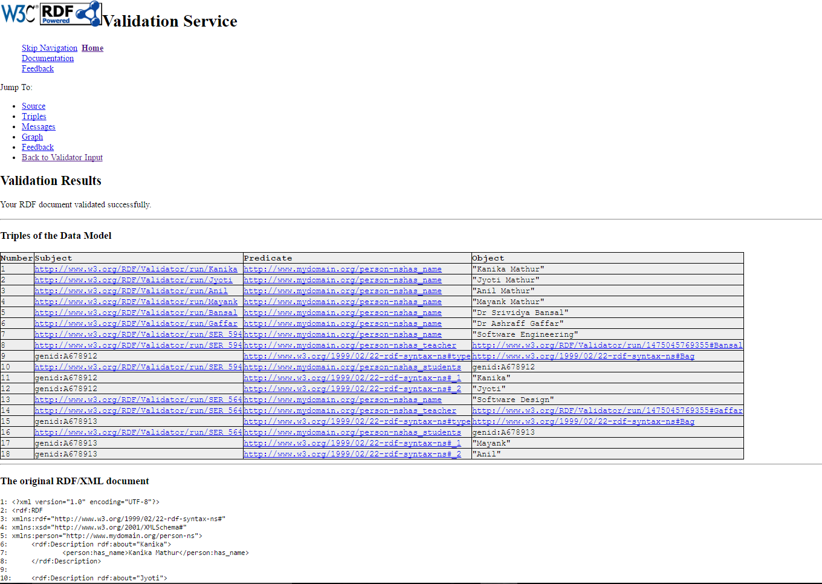

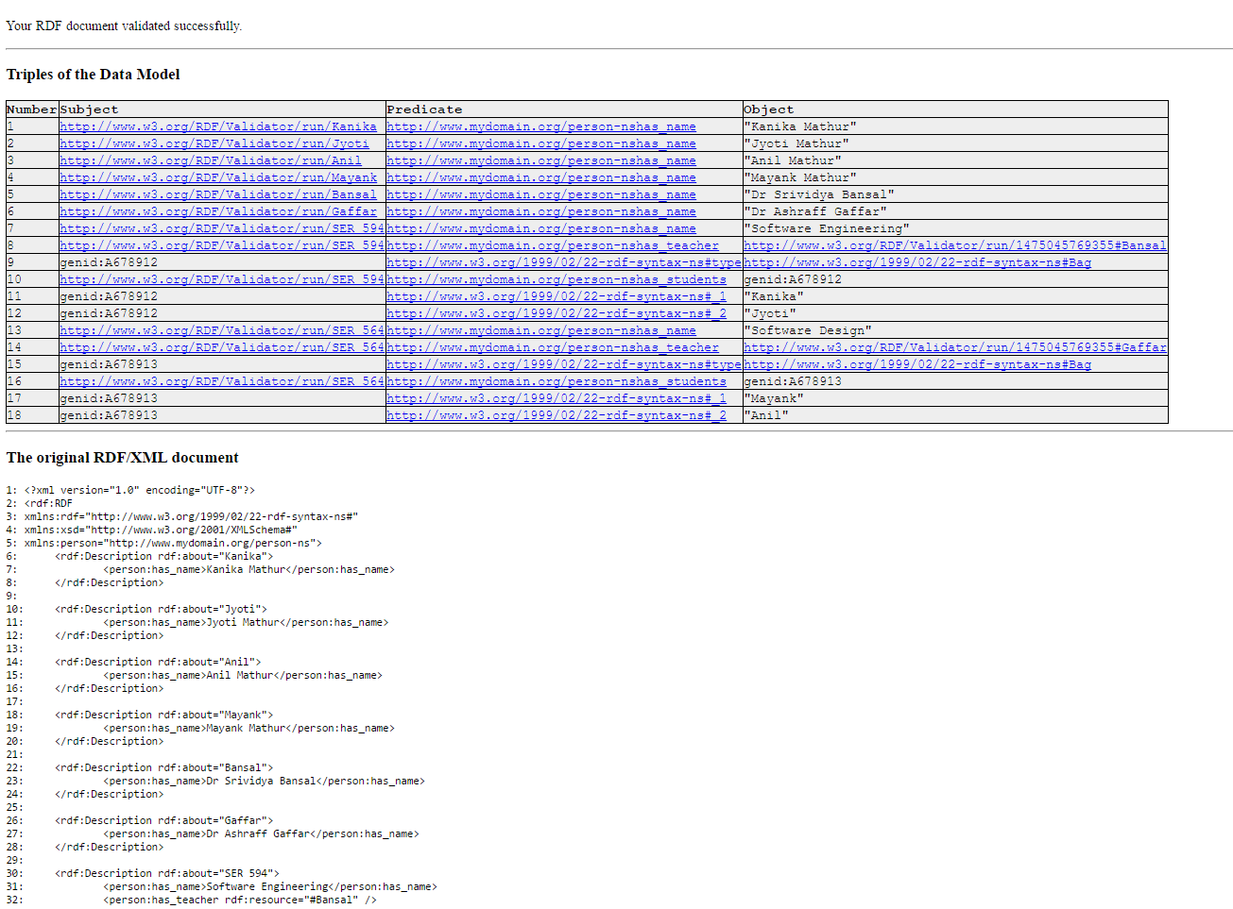

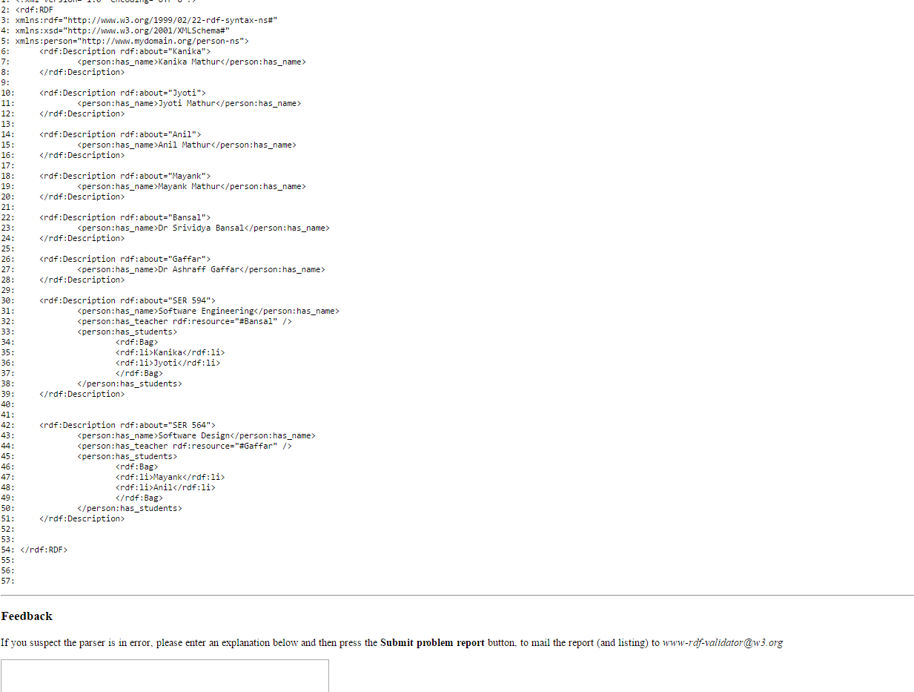

**Q5) . Review FuelEconomy data published by U.S. department of Energy (http://www.fueleconomy.gov/feg/download.shtml). More specifically look at data for 2013 and the corresponding documentation. Identify the schema representation for this dataset and depict it as a graph showing the possible classes, properties, and their relationships. Also look at FuelExonony.gov web services (http://www.fueleconomy.gov/feg/ws/index.shtml) provided for developers to gain a better understanding of this dataset.**

